Group 17
Project 2
Computer Science 313

Members
Ryan Allen  Student Email: 26221527@sun.ac.za | Courtney Campbell  Student Email: 27906124@sun.ac.za | Erin Painting  Student Email: 27023931@sun.ac.za | Kayla De Beer  Student Email: 27480216@sun.ac.za
Role: Server | Role: Client | Role: UI | Role: Server
RBUDPReceiver.java  Experiment 1 | Packet.java  Sender.java  Experiment 3 | RecieverController.java  SenderController.java  MainApp.java  ReceiverUI.java  SenderUI.java  Makefile  README.md | Experiment 2  Experiment 4

1. Introduction / Overview
This report documents the implementation and experimental evaluation of Reliable Blast UDP (RBUDP), a file transfer protocol designed to achieve high throughput by transmitting bulk data over UDP. The project involved developing a sender and receiver application with graphical user interfaces. In this system, the sender transmits file data as UDP packets, while the protocol ensures reliability through internal mechanisms for handling missing or out-of-order packets. The report presents four experiments evaluating the protocol's performance: a throughput comparison between RBUDP and TCP, an analysis of transfer rates across different file sizes, an investigation of the effect of varying packet sizes, and a study of the protocol's behaviour under simulated packet loss.

2. AI Declaration
- Gemini was used to get a skeleton for the sender file and assist with comments
- Claude was used to help debug when compiling errors were received
- ChatGPT was used to explain and break down the project and what needed to be implemented
- Claude was used to help create the Makefile
- ChatGPT was used to correct grammar and make the report consistent
- ChatGPT was used to help write a clean README
- Claude was used to help with styling consistency in the UI
- Gemini was used to teach me the concepts as well as skeleton for the server side
- ChatGPT was used to clearly describe onProgress parameter in method-level comments
- ChatGPT was used to confirm correct interpretation of experiment results
- Gemini was used to assist in making the experiment files
- Claude helped with giving a basic UI design and colors

3. Experiments

Experiment 1: Data Transfer, TCP vs RBUDP: Compare the throughput of TCP and RBUDP data transfer with varying file size
- Hypothesis: RBUDP will achieve a higher overall throughput than standard TCP across a virtual local network. Because RBUDP utilizes a single continuous UDP blast and selective NACKs, it avoids the continuous, per-packet acknowledgment overhead that limits TCP transfer speeds.
- Methods:
- Select four test files of varying sizes (e.g., 1MB, 10MB, 50MB, and 100MB).
- Transfer each file from the Sender to the Receiver using the TCP baseline method.
- Record the total time taken (in milliseconds) from the start of the transfer to completion.
- Transfer the exact same files using the RBUDP engine.
- Record the total time taken for RBUDP (including all retransmission blasts).
- Calculate the throughput (Megabytes per second) for each trial.
- Measurements & Visualisation:

- Conclusion: Although it was hypothesized that UDP would be better due to its lower protocol overhead, the data disproved it. TCP consistently hit a throughput ceiling of around 30 MB/s regardless of file size. RBUDP had an increase from 3.64 MB/s (at 1MB file size) to 11.53 MB/s (for 100MB file size) but never came close to TCP. After some research i can only think of congestion control, TCP has it built-in and UDP does not. This possibly was too much for the Tailscale network and couldn’t process all the information and led to dropped packets and time fixing errors.

Experiment 2: Transfer Rate: Testing the consistency of transfer rate in RBUDP
- Hypothesis: The RBUDP transfer rate will remain relatively stable across multiple transfers of the same file but will ultimately be bottlenecked by either the physical network interface limits or the CPU overhead.
- Methods:
  - Select a static, moderately large payload (e.g., 50MB).
  - Execute 15 consecutive RBUDP transfers of this file over the network during a period of stable network activity.
  - Record the transfer rate (MB/s) for each individual trial to establish a baseline average and observe variance.
- Measurements & Visualisation:
Experiment 2: Trial & Transfer Rate
Trial Number (Independent) | Transfer Rate (MBps) (Dependent)
1 | 0,338678
2 | 0,512521
3 | 0,669119
4 | 0,689583
5 | 0,666656
6 | 0,703105
7 | 0,705658
8 | 0,708928
9 | 0,707228
10 | 0,70947
11 | 0,706114
12 | 0,708681
13 | 0,707903
14 | 0,702526
15 | 0,536561
Variance | 0,011412
Coefficient of Variance | 16,40%
Variance (excl. Trial 1) | 0,004224
Coefficient of Variance (excl. Trial 1) | 9,64%
Table with output from experiment and computed variance. Note that the coefficient of variance decreases significantly with the exclusion of the first trial.
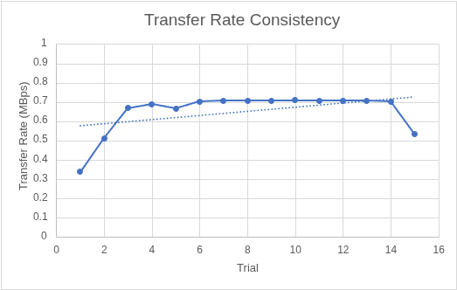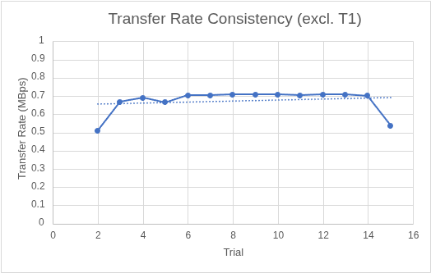
Graph 1 shows a scatter plot showing the transfer rate across the 15 trials, including a trendline to visualize consistency. Graph 2 shows a scatter plot showing the transfer rate across 14 of the 15 trials, excluding the first one. Note that the trendline shows a lot more consistency compared to the previous graph.
- Conclusion: The experiment revealed that the transfer rate remains quite stable, as the hypothesis predicted. However, no “bottlenecking” is observed. A likely reason for the lower transfer rates is the need for retransmission in that specific instance, such as Trials 2 and 15. Limitations: Repeated runs of the experiment showed a consistently low transfer rate for the first trial. A likely reason is startup overhead, which is common in networking.

Experiment 3: Packet Size: Testing the effect of Packet Size on RBUDP Transfer Time
- Hypothesis: Chunk sizes that are too small will result in excessive header/serialization overhead and lower throughput. Chunk sizes that are too large will cause IP-layer fragmentation, leading to higher packet drop rates and slower transfers.
- Methods:
  - Generate a 500KB text file. A small payload over localhost (127.0.0.1) was used to ensure zero packet drops, isolating pure processing and serialization overhead.
  - Use a custom headless script to bypass GUI bottlenecks and interact directly with the Sender and Receiver classes.
  - Test chunk sizes of 100, 500, 800, 1200, and 2000 bytes.
  - Record the total transfer time from the start of the UDP blast to the final disk write.
- Measurements & Visualisation:
Independend: Chunk Size (bytes) | Dependent: Time taken(ms)
100 | 158
500 | 32
800 | 25
1200 | 19
2000 | 9
- Conclusion: The data collected confirms that small chunk sizes increase transfer time due to serialized overhead. Even though the standard network performance typically degrades after a chunk size of 1500, this experiment showed that the 2000-byte chunk was that fasted. This is due to the experiment being run over a local loopback interface which makes the theoretical MTU limit much higher. Without physical network fragmentation, the largest chunk size simply benefited from having the absolute lowest packet count and processing overhead. The exact values do vary when rerunning the experiment; however, it always follows the same trend.

Experiment 4: Packet Loss: Testing the effect of packet loss on Throughput - RBUDP vs. TCP
- Hypothesis: Both protocols will see a decrease in throughput as buffer size decreases. When the buffer reaches capacity, incoming packets are dropped, which simulates congestion-induced packet loss. The throughput of TCP will degrade quicker than the throughput of RBUDP due to their different responses to increased packet loss. TCP’s congestion control mechanisms cause slower transmission, whilst RBUDP does not decrease throughput but will have to increase the number of retransmissions.
- Methods:
  - Simulate artificial congestion by limiting buffer size to mimic a network queue
  - Test RBUDP vs. TCP transfer of a 20MB file at buffer sizes {64KB, 32KB, 16KB, 8KB, 4KB, 2KB, 1KB}
  - For RBUDP, record number of packet drops as a supporting metric
  - Record the transfer time of each protocol in each case
  - Calculate the transfer rate from the transfer times
- Measurements & Visualisation:
Independent Variable: Buffer Size (simulate different levels of congestion)
Dependent Variable: Transfer Rate
Control Variables: Packet/Chunk Size in RBUDP and TCP
A table showing the output from Experiment 4
Buffer Size (B) | Protocol | Time (ms) | Throughput (MB/s) | Dropped Packets
65536 | TCP | 129 | 162.6 | -
32768 | TCP | 132 | 158.9 | -
16384 | TCP | 139 | 150.9 | -
8192 | TCP | 165 | 127.1 | -
4096 | TCP | 204 | 102.8 | -
2048 | TCP | 251 | 83.6 | -
1024 | TCP | 524 | 40.0 | -
65536 | RBUDP | 1,221 | 17.2 | 7254
32768 | RBUDP | 1,707 | 12.3 | 7635
16384 | RBUDP | 1,256 | 16.7 | 4641
8192 | RBUDP | 1,212 | 17.3 | 7081
4096 | RBUDP | 1,668 | 12.6 | 7307
2048 | RBUDP | 3,053 | 6.9 | 7278
1024 | RBUDP | 2,139 | 9.8 | 7322
A line graph plotting Buffer size against Transfer rate, with legends for RBUDP and TCP.
- Conclusion: The results support the hypothesis, where we see a decrease in throughput for both protocols and a dramatic decrease in TCP. The simulated artificial congestion worked exactly as expected for TCP. While TCP’s throughput was higher, TCP’s behaviour was reactive to prevent packet loss, while RBUDP remained aggressive, just as intended. However, the graph clearly shows that there was a gap in the hypothesis with the big difference in throughput between the two protocols. What should have been taken into consideration is that the experiment was done on “localhost”, where TCP ACKs are nearly instant. RBUDP suffers more in this implementation due to the overhead of the repair phase and deserialisation latency. Limitations: The two protocols can be better compared in an environment that does not favour one protocol over the other

